**PROJECT NAME:- CLOUD COMPUTING USING INTRANET**

**NAME, ROLL NO. AND CONTACT INFORMATION OF GROUP MEMBERS:-**

* Utkarsh Kore
* Roll no.:- 10
* E-mail- [utkarshkore98@gmail.com](mailto:utkarshkore98@gmail.com)
* Contact no.:- 8693886401
* Niraj Palkar
* Roll no.:- 14
* E-mail- [nirajp526@gmail.com](mailto:nirajp526@gmail.com)
* Contact no.:- 8879017985
* Harsh Tarkar
* Roll no.:- 15
* E-mail- [tarkar.harsh@gmail.com](mailto:tarkar.harsh@gmail.com)
* Contact no.:- 9820880693
* Omkar Dongre
* Roll no.:- 22
* E-mail- omkardongre29@gmail.com
* Contact no.:- 9987483146
* **NAME OF GUIDE:-** Ms.Poonam S. Wavare
* **ABSTRACT AND KEYWORDS**

**KEY CONCEPTS**

**1) CLOUD COMPUTING-**

Cloud computing is a type of Internet-based computing that provides shared computer processing resources and data to computers and other devices on demand. It is a model for enabling ubiquitous, on-demand access to a shared pool of configurable computing resources (e.g., computer networks, servers, storage, applications and services), which can be rapidly provisioned and released with minimal management effort.

**2) INTRANET-**

An intranet is a private network accessible only to an organization's staff. Generally a wide range of information and services from the organization's internal IT systems are available that would not be available to the public from the Internet. A company-wide intranet can constitute an important focal point of internal communication and collaboration, and provide a single starting point to access internal and external resources. In its simplest form an intranet is established with the technologies for local area networks (LANs) and wide area networks (WANs).

**3) MULTITHREADING:**

Server has to accept the client connection infinitely and receive the data from the client infinitely. Similarly client has to receive the data infinitely. Hence thread is used in the above cases.

**4) NETWORK CONNECTION DETECTOR:**

If the username and password is correct, logged on username is sent to other clients and to server. Thus the logged on username will occur in the client list box and in the server list box. When the user is logged off, his name is deleted in the server log on user list and in other client log on user list.

**5) ACTIVE FRIENDS LIST:**

In server, database is created I the logged on username to add his friends name. In client, we can add any one of the logged on users in the list box as friend in the database after getting the indication from that particular user that their name can be added in the friends list.

**6) CREATING AND SAVING LOG FILES:**

The log files are created in server and saved in the database. Whenever needed the log file is opened.

* **SHORT WORKING OF PROJECT:- CLOUD COMPUTING USING INTRANET**

**CLIENT-SERVER FRAMEWORK**

Client will communicate to other clients through server. Messages will be sent from client to server and then from server to other client.

**Client Server Client**

# Request/Reply

**Message Message**

**NETWORK**

Socket

Request/Reply

Client

Socket

Client

Socket

Server Socket

Socket

**MULTITHREADING-** Server will keep accepting clients.

Server

Thread

Client

Multi Threading

Client

Client

Client

**CLIENT SERVER COMMUNICATION**

Connection Success

CLIENT

SERVER

**CLIENT ACCESSING CLOUD THROUGH SERVER**

Server

Cloud

Client

**LEVEL 0 DFD**

Client asks for services from cloud

Check for space

Cloud storage

Client

Cloud

Verification

Allocated space

Directory

In this project we will provide the services of cloud using Intranet. The client will ask for cloud services from the cloud. The cloud will verify that the client is a verified member of organization and ask him for authentication. After authentication the cloud will check for space and if available allocate it to the client.

**LEVEL 1 DFD**

Cloud Storage

Client info database

2

1

Check for valid info

Check for space

Client asks for services from cloud

Check request

Cloud

Verification

Cloud storage

Management

Client

Allocated space

Directory

Update storage info

3

Provided Services database

* **DESIGN OF FORMS:-**

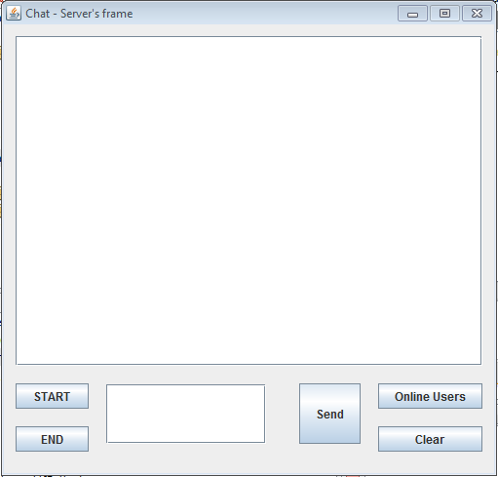

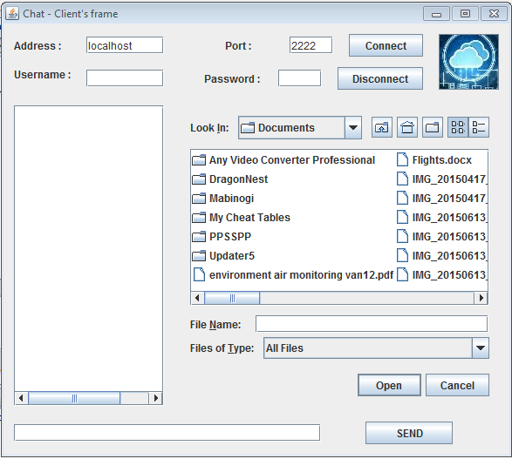

* **WORKING OF PROJECT**

The project that is to be developed is a communication between a server and number of clients. Communication between different clients is done through sockets. This can be implemented using the sockets and serversocket classes. The requested choice is sent to the server and the communication takes place. The server is anything that has some resource that can be shared. A client is simply and other entity that wants to gain access to a particular server.

**1) REQUEST OF SERVICES:-**

First the client requests the services from cloud. The client has to authenticate by using his user name and password to access the services. If the user doesn’t have an account he can create a new account by filling the given details. The information of client will be saved in Client info database.

**2) VERIFICATION:-**

The data of client will be verified by comparing it with the copy of data in Client info database. If client doesn’t have an account and is creating a new account this information will be added into the database for first time. The Program will also check for used Usernames to avoid redundancy.

**3) STORAGE MANAGEMENT:-**

After verification the Cloud Storage Manager will receive client’s request. The program will check if the space is available and allocate it to the client using Intranet.

**4) UPDATE DATABASES:-**

Once the allocation of storage has been completed we need to update the Cloud storage database and provided service database. After allocation of data the Cloud storage database will reduce its space by removing the allocated space. The provided service database will show information about the services that are currently allocated to the clients.

The client info database will also be updated so that he cannot request more than a specific limit. If the client wants more services he will have to pay a small fee on a monthly or yearly basis.

**5) RECEIVING SERVICES:-**

The client will receive services from cloud and can access the data from anywhere using his username and password.

**6) FILE TRANSFER:-**

File transfer is handled between clients. To share a file from another client, the requestor client sends the request to the server. The server then gets the file from the client, which provides the requested file. Then the server sends the file to the requestor client. When the request from the server is sent to the provider, a File Dialog Box is displayed in open mode. The requested file is selected from the FileDialogBox and sent to the server. The server sends the file to the requestor, and the requested file is saved using a File Dialog Box in save mode.

* **SYSTEM CONFIGURATION**

**HARDWARE REQUIREMENTS:**

PROCESSOR : Pentium 4

RAM : 64 MB

SPEED : 500 MHZ

HARD DISK DRIVE : 20 GB

FLOPPY DRIVE : 3.5 “inch

INPUT DEVICES : Keyboard and Mouse

**SOFTWARE REQUIREMENTS:**

OPERATING SYSTEM : Windows2000/95/98/NT

LANGUAGE : Java

* **SCHEDULED COMPLETION OF PROJECT:-** 28/02/2017
* **FEATURES OF PROJECT:-**

1) Our Project will help solve many small problems related to managing servers, sharing, security and storage.

2) It will be cost effective.

3) Its minimum requirements required for project are less.

4) Authentication will provide better security.

5) Databases and monitoring of services provided.

6) Ability to access data from anywhere.

7) Integrity of data.

* **FUTURE DEVELOPMENTS:-**

1) We can encrypt the data which the user will add to the cloud to avoid man in the middle attack while data is in transit.

2) Increase the amount of storage allowed to client at the creation of account for free.

3) Allow wireless connectivity.

* **REFERENCES:-**

<https://en.wikipedia.org>

<http://projectsgeek.com>

[www.javatpoint.com](http://www.javatpoint.com)